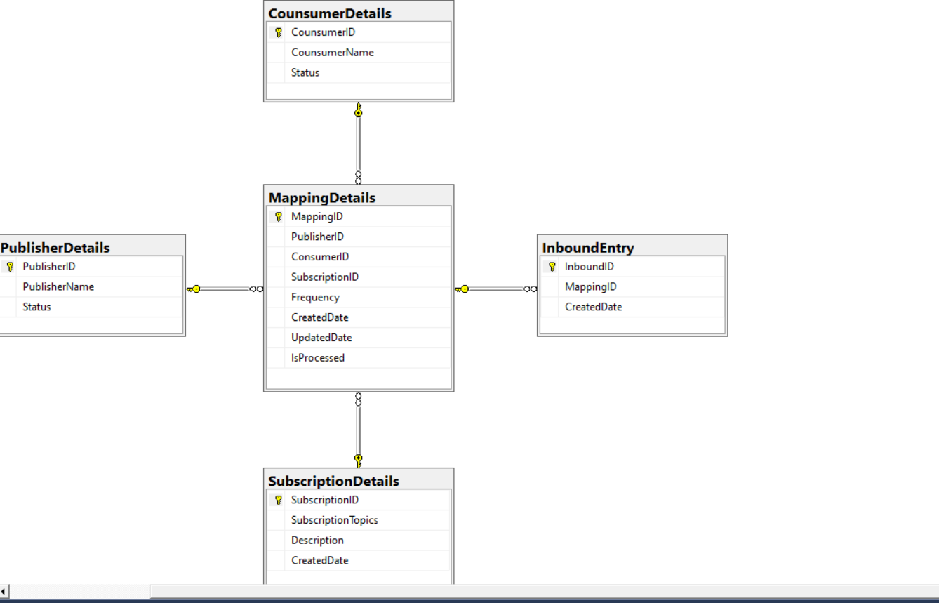

Inbound Console application:

Console application should convert into executable format and run through task scheduler job on demand /Daily/Hourly based on configuration.

Application will read data from mapping details and enter data for top 1 record of publisher and consumer combination records. At a time consumer can receive one message/data from each publisher.

outbound Console application:

Console application should convert into executable format and run through task scheduler job on demand /Daily/Hourly based on configuration

It will read data from inbound entry table and delivered to outbound table as one record for publisher-consumer combination.

Once cousumer login into UI and see top priority message/data from each publisher.